Homework 3

Cooper Honeywell

2024-05-30

Table of contents

https://github.com/cooper-honeywell/honeywell_cooper_homework-03.git

library(tidyverse)  
library(readxl)  
library(here)  
library(janitor)  
library(GGally)  
library(MuMIn)  
library(ggeffects)  
library(gtsummary)  
library(flextable)  
library(modelsummary)

### Problem 1:

#### a. Table

model_table <- read.csv("model_table.csv") #read in dataset that will be our table  
flextable::as_flextable(model_table) #use flextable to turn dataset -> table

| Model | Predictor..1 | Predictor..2 | Predictor..3 |
| --- | --- | --- | --- |
| character | character | character | character |
| model0 | n/a | n/a | n/a |
| model1 | SLA | water_treatment | species |
| model2 | SLA | water_treatment | n/a |
| model3 | SLA | n/a | species |
| model4 | n/a | water_treatment | species |
| n: 5 | | | |

##### Table 1: Predictor Variables Distribution Among Models

The table rows correspond to an individual model that was evaluated. Each column is a possible predictor variable that is used to make the model. An “n/a” signifies that that particular model does not contain that variable at all. ie: Model 0 does not contain any of the predictor variables, making it the null model, Model 1 contains all three predictor variables making it the saturated model.

b. Methods:

To examine the influence of Specific leaf area (SLA), water treatment, and species type on total biomass, . We conducted some exploratory visualization to see any immediate trends on our data like which species has the highest mean biomass, which water treatment corresponded to a higher biomass and if there was a correlation between SLA and biomass using a scatter plot and Pearson’s r. We then constructed 5 models, including our null model, saturated model and the three models containing a unique combination of two predictors. To evaluate these models, we first evaluated their diagnostics, finding no trends or outliers that would affect our data. To determine the model that best described the effect on total biomass, we produced AIC values for each model, finding that model 4, using species and water treatment a predictors was the model that showed the relationship with total biomass the best. We then produced a visualization of the effects of water treatment, and species on total biomass.

drought_exp <- read_xlsx(path = here("data",   
 "Valliere_etal_EcoApps_Data.xlsx"),  
 sheet = "First Harvest")  
drought_exp_clean <- drought_exp %>%   
 clean_names() %>% # nicer column names  
 mutate(species_name = case_when( # adding column with species scientific names  
 species == "ENCCAL" ~ "Encelia californica", # bush sunflower  
 species == "ESCCAL" ~ "Eschscholzia californica", # California poppy  
 species == "PENCEN" ~ "Penstemon centranthifolius", # Scarlet bugler  
 species == "GRICAM" ~ "Grindelia camporum", # great valley gumweed  
 species == "SALLEU" ~ "Salvia leucophylla", # Purple sage  
 species == "STIPUL" ~ "Nasella pulchra", # Purple needlegrass  
 species == "LOTSCO" ~ "Acmispon glaber" # deerweed  
 )) %>%   
 relocate(species_name, .after = species) %>% # moving species_name column after species  
 mutate(water_treatment = case_when( # adding column with full treatment names  
 water == "WW" ~ "Well watered",  
 water == "DS" ~ "Drought stressed"  
 )) %>%   
 relocate(water_treatment, .after = water) # moving water_treatment column after water  
  
model4 <- lm(total_g ~ water_treatment + species_name,  
 data = drought_exp_clean)  
model_preds4 <- ggpredict(model4,   
 terms = c( "species_name",   
 "water_treatment"))

1. Creating Visualization

* type_colors <- c("Well watered" = "dodgerblue1", "Drought stressed" = "sienna")   
  ggplot() + # assigning colors to treatment  
   geom_point(data = drought_exp_clean, # underlying data  
   aes(x = water_treatment,  
   y = total_g,  
   alpha = 0.2,  
   color = water_treatment)) +   
   scale_color_manual(values = type_colors) + # Specified manual color scale   
   facet_wrap(~species_name) + # creating different panels for species  
   geom_point(data = model_preds4, # model prediction value added  
   aes(x = group,   
   y = predicted),   
   color = "black",  
   size = 2) + # making the predicted points larger for visibility  
   geom_errorbar(data = model_preds4,   
   aes(x = group, # whiskers for confidence interval  
   ymin = conf.low,   
   ymax = conf.high),   
   width = 0.2,   
   color = "black") +  
   facet_wrap(~x)+ # faceting the dot & whisker among species  
   theme_classic() + # cleaning up plot  
   theme(panel.spacing = unit(1, "lines"))+ # spacing out panels  
   labs(x = "Water Treatment", y = "Total Mass (g)")+ # plot titles  
   theme(legend.position = "none") #removing the legend
* 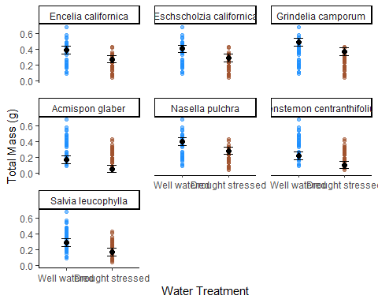

1. Figure 1: Total plant mass predicted by water treatment and species.

* This figure features the underlying data of the observations of plant mass across seven flower and grass species. Each species was subjected to two different water treatments, well watered (blue) and simulating drought (brown). On top of the observations is the model predicted value along with our confidence interval represented by the black dot and whiskers.
* Valliere, Zhang, Sharifi, Rundel (2019) “Can we condition native plants to increase drought tolerance and improve restoration success?” [Dataset] [**https://doi.org/10.1002/eap.1863**](https://doi.org/10.1002/eap.1863)

e. Results

We used AIC model selection to determine which variables best described the response of total mass. The best fit model, carrying 77% of all of the predictive power between models, used the species it self, and water treatment (well watered vs. drought stressed) to predict total plant mass. On average, we found that well watered plants had higher total mass when compared plants under drought stressed conditions. On average, Grindelia camporum (Great Valley Gumweeed), has the highest mean total mass, and Acmispon glaber (Deerweed), has the lowest mean total mass.

#### Problem 2:

1. To affectively visualize my personal data, I was thinking of doing something similar to the Dear Data project. I would make an entry everyday of the week, inclusing symbols that describe my data. Each entry would signify a day and how many times I went to the arbor, how many times I visited the grass, as well as if I was was with friends or not.
2. Sketch

* 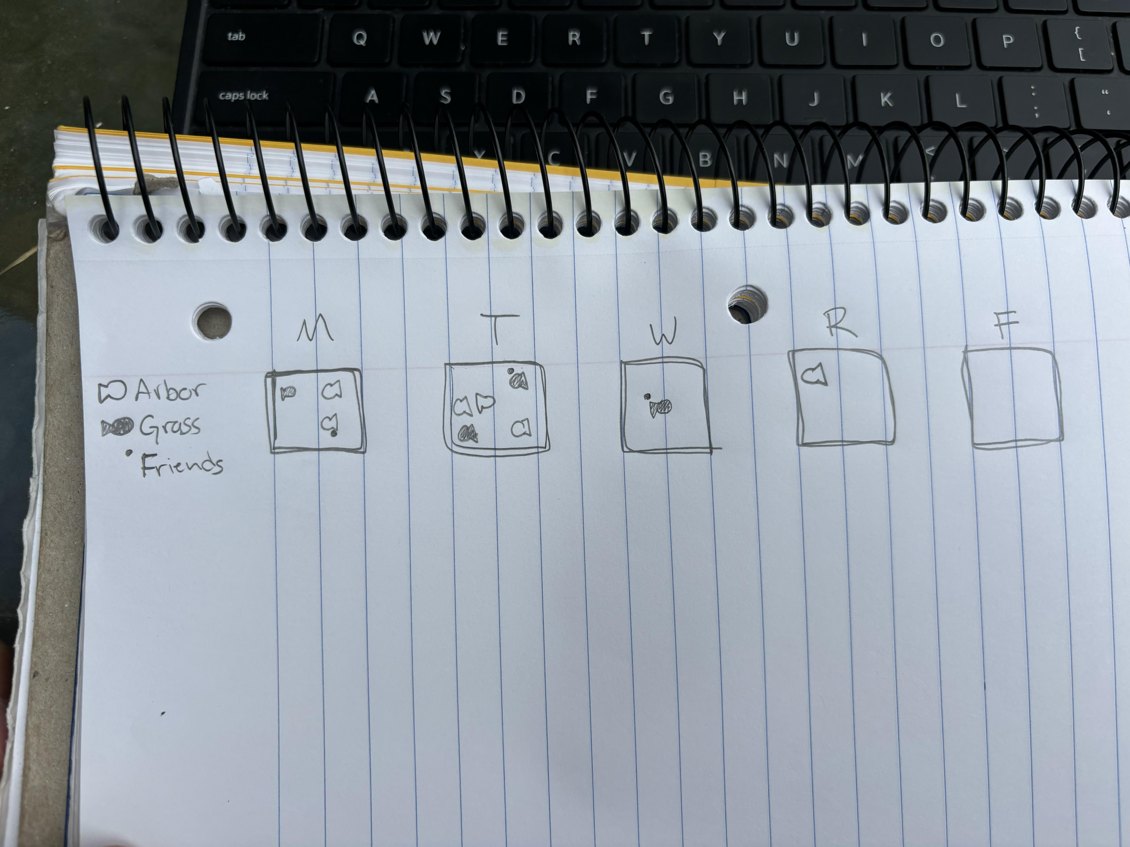

1. Draft

* 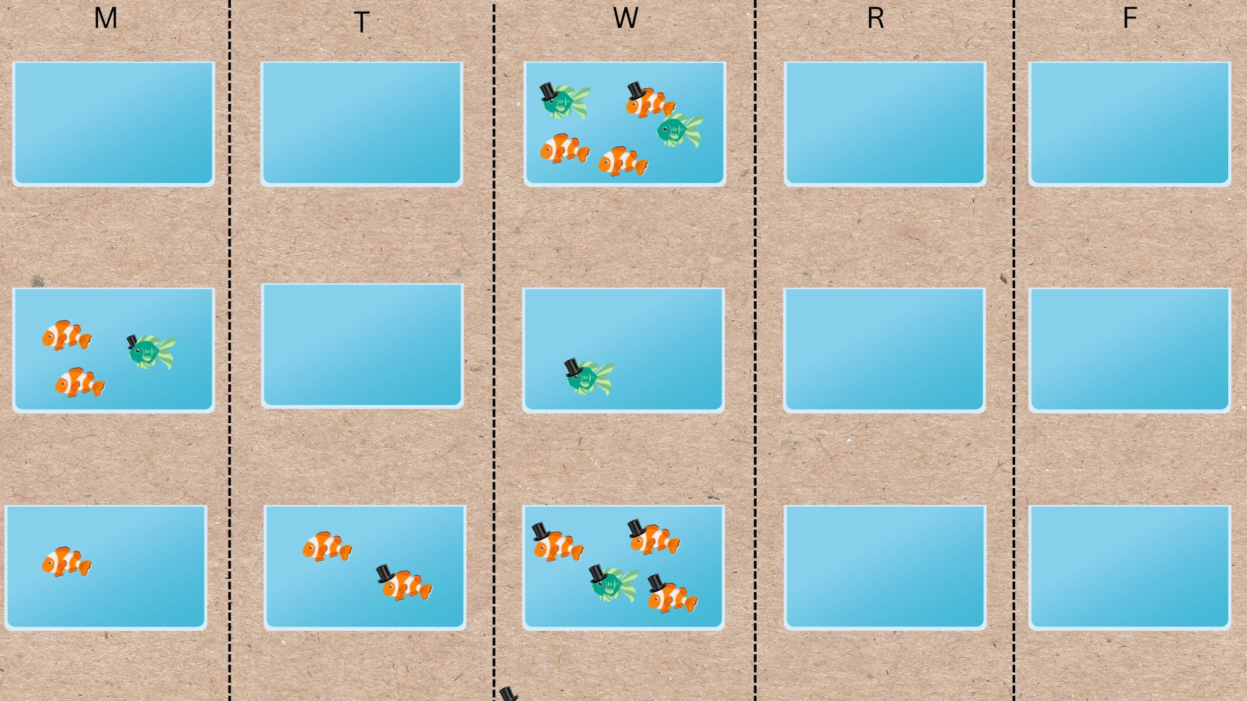

1. Artist Statement

This piece is showing the frequency in which I visit the Arbor and grass in front of the UCSB library respectively, as well as if I visited those places with friends or alone. It is separated by day of the week with a separate row for each week. Each fish tank corresponds to one day, fish type corresponds either the Arbor (orange), or the grass (green), and a top hat signifies that I was with friends during that visit. I created this piece digitally on the platform Canva. It was influenced by the Dear Data postcard project where different things were tracked and documented on a postcard using symbols.

### Problem 3: Statistical Critique

1. Summary

The authors used a Mann-Whitney-U Test to evaluate differences in the use of altitude ranges by both snow and common leopards to determine how much their geographical ranges overlap. They also compiled data from studies depicting the diets of each leopard and summarized it to describe how much of each leopards diet consists of a certain group of prey to explore the overlap in the two predators diets. All to determine the likelihood of competition between two species that used to be separated by thousands of feet in elevation.

**Fig. 1. Diet composition in terms of frequency of occurrence of domestic prey (black), wild prey i.e. mammals and birds (white) and other prey e.g. amphibians, reptiles etc. (grey) in common leopard (*Panthera pardus*) and snow leopard (*Panthera uncia*) with respect to study sites and distribution range (IUCN 2012, modified). Study areas: CL, 1 – Lukarewsky**[**Citation1988**](https://www.tandfonline.com/doi/full/10.1080/03949370.2013.806362?casa_token=aia1DdgfIocAAAAA%3A8a_ga0d4j9WyhL4PnI3Pxs55sAxadQDPVJ8u8SRmH9wHjJfClBKSm-WFWfSkXQGcvF3oNIMqEOh4RQ#)**; 2 – Schaller**[**Citation1977**](https://www.tandfonline.com/doi/full/10.1080/03949370.2013.806362?casa_token=aia1DdgfIocAAAAA%3A8a_ga0d4j9WyhL4PnI3Pxs55sAxadQDPVJ8u8SRmH9wHjJfClBKSm-WFWfSkXQGcvF3oNIMqEOh4RQ#)**; 3 – Khandal & Srivastava (unpublished); 4 – Wegge et al.**[**Citation2009**](https://www.tandfonline.com/doi/full/10.1080/03949370.2013.806362?casa_token=aia1DdgfIocAAAAA%3A8a_ga0d4j9WyhL4PnI3Pxs55sAxadQDPVJ8u8SRmH9wHjJfClBKSm-WFWfSkXQGcvF3oNIMqEOh4RQ#)**; 5 (Deurali area); 6 (Sagarmatha) – Lovari (unpublished); 7 – Johnson et al.**[**Citation1993**](https://www.tandfonline.com/doi/full/10.1080/03949370.2013.806362?casa_token=aia1DdgfIocAAAAA%3A8a_ga0d4j9WyhL4PnI3Pxs55sAxadQDPVJ8u8SRmH9wHjJfClBKSm-WFWfSkXQGcvF3oNIMqEOh4RQ#)**; 8 – Bandipur area (Johnsingh**[**Citation1992**](https://www.tandfonline.com/doi/full/10.1080/03949370.2013.806362?casa_token=aia1DdgfIocAAAAA%3A8a_ga0d4j9WyhL4PnI3Pxs55sAxadQDPVJ8u8SRmH9wHjJfClBKSm-WFWfSkXQGcvF3oNIMqEOh4RQ#)**; Karanth & Sunquist**[**Citation1995**](https://www.tandfonline.com/doi/full/10.1080/03949370.2013.806362?casa_token=aia1DdgfIocAAAAA%3A8a_ga0d4j9WyhL4PnI3Pxs55sAxadQDPVJ8u8SRmH9wHjJfClBKSm-WFWfSkXQGcvF3oNIMqEOh4RQ#)**; Andheria et al.**[**Citation2007**](https://www.tandfonline.com/doi/full/10.1080/03949370.2013.806362?casa_token=aia1DdgfIocAAAAA%3A8a_ga0d4j9WyhL4PnI3Pxs55sAxadQDPVJ8u8SRmH9wHjJfClBKSm-WFWfSkXQGcvF3oNIMqEOh4RQ#)**); 9 – Sathyakumar**[**Citation1992**](https://www.tandfonline.com/doi/full/10.1080/03949370.2013.806362?casa_token=aia1DdgfIocAAAAA%3A8a_ga0d4j9WyhL4PnI3Pxs55sAxadQDPVJ8u8SRmH9wHjJfClBKSm-WFWfSkXQGcvF3oNIMqEOh4RQ#)**; 10 (Doi Mon Jong) – Lovari (unpublished); 11 – Rabinowitz**[**Citation1989**](https://www.tandfonline.com/doi/full/10.1080/03949370.2013.806362?casa_token=aia1DdgfIocAAAAA%3A8a_ga0d4j9WyhL4PnI3Pxs55sAxadQDPVJ8u8SRmH9wHjJfClBKSm-WFWfSkXQGcvF3oNIMqEOh4RQ#)**. SL, 1 – Schaller et al.**[**Citation1988b**](https://www.tandfonline.com/doi/full/10.1080/03949370.2013.806362?casa_token=aia1DdgfIocAAAAA%3A8a_ga0d4j9WyhL4PnI3Pxs55sAxadQDPVJ8u8SRmH9wHjJfClBKSm-WFWfSkXQGcvF3oNIMqEOh4RQ#)**; 2 – Schaller et al.**[**Citation1987**](https://www.tandfonline.com/doi/full/10.1080/03949370.2013.806362?casa_token=aia1DdgfIocAAAAA%3A8a_ga0d4j9WyhL4PnI3Pxs55sAxadQDPVJ8u8SRmH9wHjJfClBKSm-WFWfSkXQGcvF3oNIMqEOh4RQ#)**; 3, 7, 8 – Schaller**[**Citation1977**](https://www.tandfonline.com/doi/full/10.1080/03949370.2013.806362?casa_token=aia1DdgfIocAAAAA%3A8a_ga0d4j9WyhL4PnI3Pxs55sAxadQDPVJ8u8SRmH9wHjJfClBKSm-WFWfSkXQGcvF3oNIMqEOh4RQ#)**; 4, 5 – Bagchi & Mishra**[**Citation2006**](https://www.tandfonline.com/doi/full/10.1080/03949370.2013.806362?casa_token=aia1DdgfIocAAAAA%3A8a_ga0d4j9WyhL4PnI3Pxs55sAxadQDPVJ8u8SRmH9wHjJfClBKSm-WFWfSkXQGcvF3oNIMqEOh4RQ#)**; 6 – Chundawat & Rawat**[**Citation1994**](https://www.tandfonline.com/doi/full/10.1080/03949370.2013.806362?casa_token=aia1DdgfIocAAAAA%3A8a_ga0d4j9WyhL4PnI3Pxs55sAxadQDPVJ8u8SRmH9wHjJfClBKSm-WFWfSkXQGcvF3oNIMqEOh4RQ#)**; 9 – Jackson**[**Citation1996**](https://www.tandfonline.com/doi/full/10.1080/03949370.2013.806362?casa_token=aia1DdgfIocAAAAA%3A8a_ga0d4j9WyhL4PnI3Pxs55sAxadQDPVJ8u8SRmH9wHjJfClBKSm-WFWfSkXQGcvF3oNIMqEOh4RQ#)**; 10 – Oli et al.**[**Citation1993**](https://www.tandfonline.com/doi/full/10.1080/03949370.2013.806362?casa_token=aia1DdgfIocAAAAA%3A8a_ga0d4j9WyhL4PnI3Pxs55sAxadQDPVJ8u8SRmH9wHjJfClBKSm-WFWfSkXQGcvF3oNIMqEOh4RQ#)**, 11 (Sagarmatha) – Lovari (unpublished); 12, 13, 14, 15, 16 – Schaller, Ren & Qiu**[**Citation1988**](https://www.tandfonline.com/doi/full/10.1080/03949370.2013.806362?casa_token=aia1DdgfIocAAAAA%3A8a_ga0d4j9WyhL4PnI3Pxs55sAxadQDPVJ8u8SRmH9wHjJfClBKSm-WFWfSkXQGcvF3oNIMqEOh4RQ#)**. Shaded area: distribution range.**

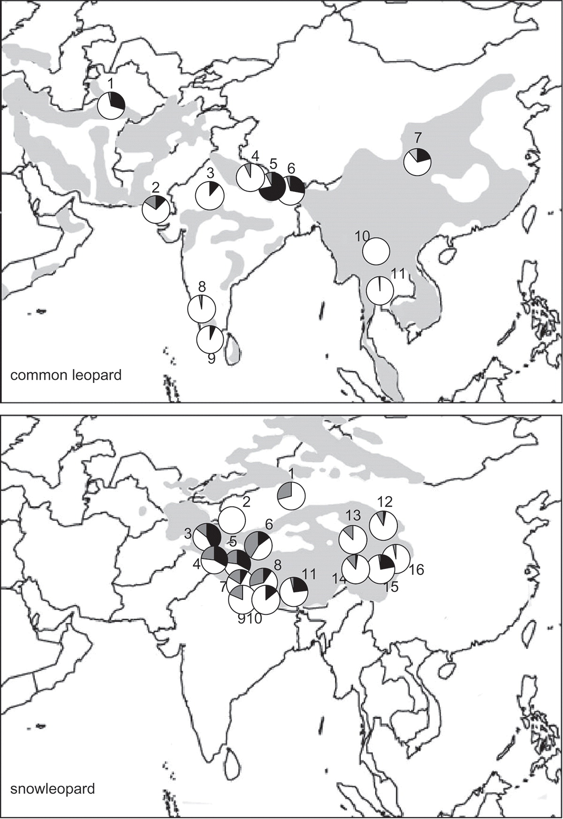

**Fig. 2. Relative frequency of occurrence (%) of prey weight categories in the common leopard (*Panthera pardus*, *n* = 11) and the snow leopard (*Panthera uncia*, *n* = 16) diets (median, quartiles). NCL = 11, NSL = 16.**

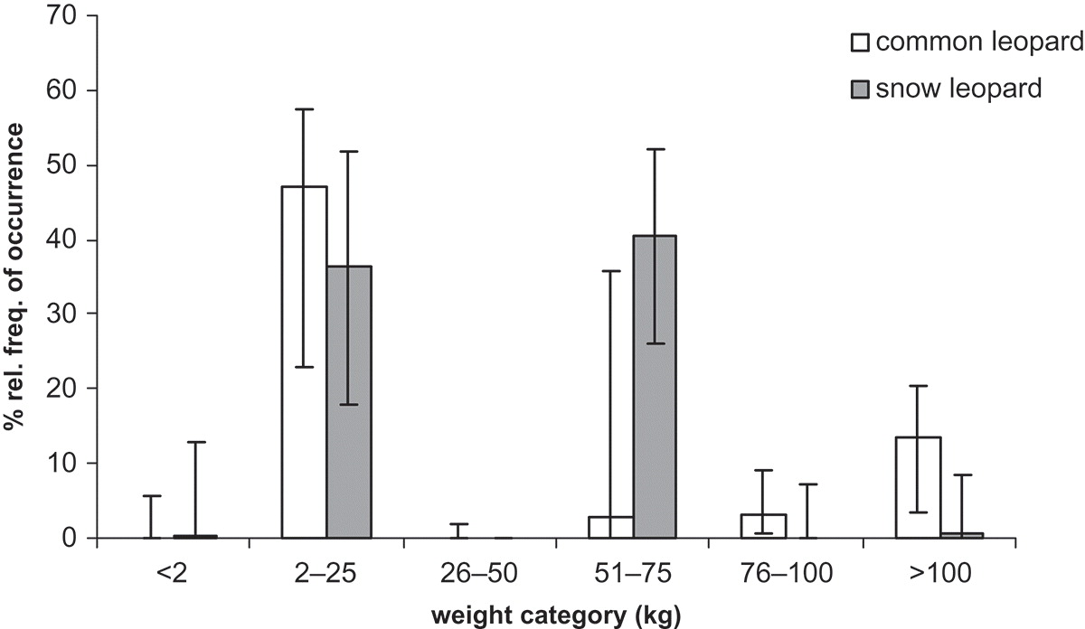

1. Visual Clarity

* Fig 1 is kind of difficult to digest as you have to refer back and forth between two maps to see where the species overlap and what their diet consists of. The pie charts represent the composition of the leopard’s diet in each location using the frequency of occurrence of prey type.
* Fig 2 is much clearer in communicating the data. The axes are clear and labeled, the bars are shaded based on species and the error bars are easy to see. They are showing the means and standard error for the prey weight categories % relative frequency of occurrence. The did not include the underlying data.

1. Aesthetics

* Fig 1 has too much visual clutter in my opinion. The borders of the maps where the leopards don’t live is distracting. The numbers corresponding to each study area/pie chart could be mistaken for something else if you don’t read the caption carefully. Having two maps to look back and forth between seems like too much clutter. I would say there is too much ink in the data:ink ratio.
* Fig 2 is a clean figure. It presents the data clearly and is not complicated to see the trends. I think it passes the data:ink ratio test.

1. Recommendations

My main recommendation would be to make one map, with two different shadings for each leopards geographic range and each study site labeled. And then paired with that they could include plots faceted by study site or elevation, comparing the diet composition of both leopards. This would make it easier to compare the two species and their diets. This would help in visualizing if there is a higher chance for competition between the leopards at different sites/elevations.